Preparing for a Remote Review

Version 1.2 August / 2022 Visit ncfe.org.uk Call 0191 239 8000

Preparing for a remote review
We want your remote review to be a positive experience therefore to ensure this runs as smoothly and efficiently as possible, we’ve provided some guidance to assist you.

Approval Review
User Guide to the Approval Report
User Guide to NCFE TQ Provider Approval (TQ Only)
TQ Deliver Staff Qualification and Experience Template (TQ Only)

Annual Monitoring Review (AMR)
AMR Centre Guidance Document User Guide to the AMR Report

EQA Review
EQA Review Centre Guidance Document User Guide to the EQA Report

Moderation Review
Moderation Review Provider Guidance Document User Guide to the Moderation Report

When a review date has been agreed, we will write to you to confirm the date and time of the review and request you complete the centre guidance document. We recommend this is completed as early as possible to state the evidence in place to meet each criterion in the report and where this evidence can be located. Completing this early, ensures you have sufficient time to
prepare and prevents delays to your review. We recognise that much of this information does not change, therefore once completed, simply ensure this remains up to date and ready to share year on year.

One week prior to your agreed review date, we require the below information from you, as outlined in our confirmation of review email. If this is not your first review, you should also refer to your previous report via the portal and ensure any actions have been addressed. All documents are available on QualHub.

Approval Review
- Completed Approval Review Centre Guidance Document
- TQ Deliver Staff Qualification and Experience Template (TQ Only)

Annual Monitoring Review (AMR)
- Completed Annual Monitoring Review (AMR) Provider Guidance Document
- Centre feedback document
- Telephone numbers and email addresses of 2 learners and a convenient time to contact them on the date of the review. You should use the Learner Feedback Form to provide this information. By completing this form, you are giving permission for learners to be contacted. This form can be found within the Course Management File Documentation folder.

EQA Review
- Completed EQA Review Centre Guidance Document
- Completed Centre Information Document
- Centre feedback document
- Telephone numbers and email addresses of 2 learners and a convenient time to contact them on the date of the review. You should use the Learner feedback form by completing this form, you provide permission for learners to be contacted. This form can be found within the Course Management File Documentation folder.
- List of learners who have had assessments adapted, where applicable
- Completed Assessment Tracking Document (Functional Skills only) – This document can be found within the Assessment materials tab on the qualification page on Qualhub. It must be completed in full and include all booked assessments i.e. passed/failed/cancelled/expired.

For Functional Skills qualifications you must also read the Regulations for the conduct of Controlled Assessment – Functional Skills.

Moderation Review
- Completed Moderation Review Provider Guidance Document

It is important that you are fully prepared for your review and all information is sent within the specified timescales. Any delays or missing evidence may result in:

- A delay to your report
- Your review being rescheduled
- Actions on your report
- A delay to learner certificates, where applicable
- A cancellation fee

How to send the information
There are various ways you can share the required information with us. Our preferred methods are outlined below. However, should you wish to use an alternative, please discuss this with us.

Serv-U - NCFE’s secure file sharing platform
If using Serv-U we will send you a link to request the files. This link will be password protected and you will be sent the password separately.

Before you start to upload your files, you must ensure you have all the evidence required, as per the above Centre Guidance document and any additional evidence requested from your EQA/Quality Reviewer (QR).

When providing learner evidence, I don’t need full portfolios. I will need the following:

- Where a qualification is skills and knowledge, I will need one piece of knowledge evidence and one piece of skills evidence per learner. Try to vary assessment methods and units provided across learners requested.
- Where a qualification involves a research project, please ensure one full research project is within the learner samples provided.
- Where a qualification requires a longitudinal study, please ensure one full longitudinal study is available for sample.
- Where a qualification contains a graded unit rather than pass/refer please ensure that all evidence relating to the final grade for that unit is provided and provide a range of unit over the learner sample.

To help us to locate the information, you’ll need to create separate folders on your computer, as labelled below. Each folder must include the information for each section as specified in the Centre Guidance document.

Files and folders must be:

- Clearly labelled, making it clear what the document is, which learner/unit/submission it relates to, where applicable
- Uploaded in full, rather than separate pages. Where documents are scanned, the pages must be uploaded the correct way up and must be of good quality
- Zip Folders, this will enable you to upload evidence much quicker. To create a zip folder.

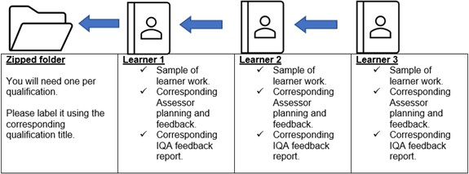

For example - Zipped Folder one will be named with the qualification title – within this please include one folder per learner sample, including sample of learner work along with corresponding Assessor planning and feedback, and IQA feedback.

Approval, EQA and AMR folders
- Management Systems and Administration Arrangements
- Resources
- Delivery and Assessment (for EQA reviews, there must be subfolders within this folder for each learner to include all their evidence)
- Internal Quality Assurance
- Learner and Centre feedback (EQA & AMR only)

Moderation folders
- Management Systems and Administration Arrangements
- Moderation (there must be subfolders within this folder for each learner to include all their evidence)

Uploading the evidence to Serv-U
- Locate our confirmation of review email with the Serv-U link
- Copy and paste the link to your browser
- Click browse to upload your Zip Folder – Management Systems and Administration Arrangements
- Continue to upload the remaining Zip Folders

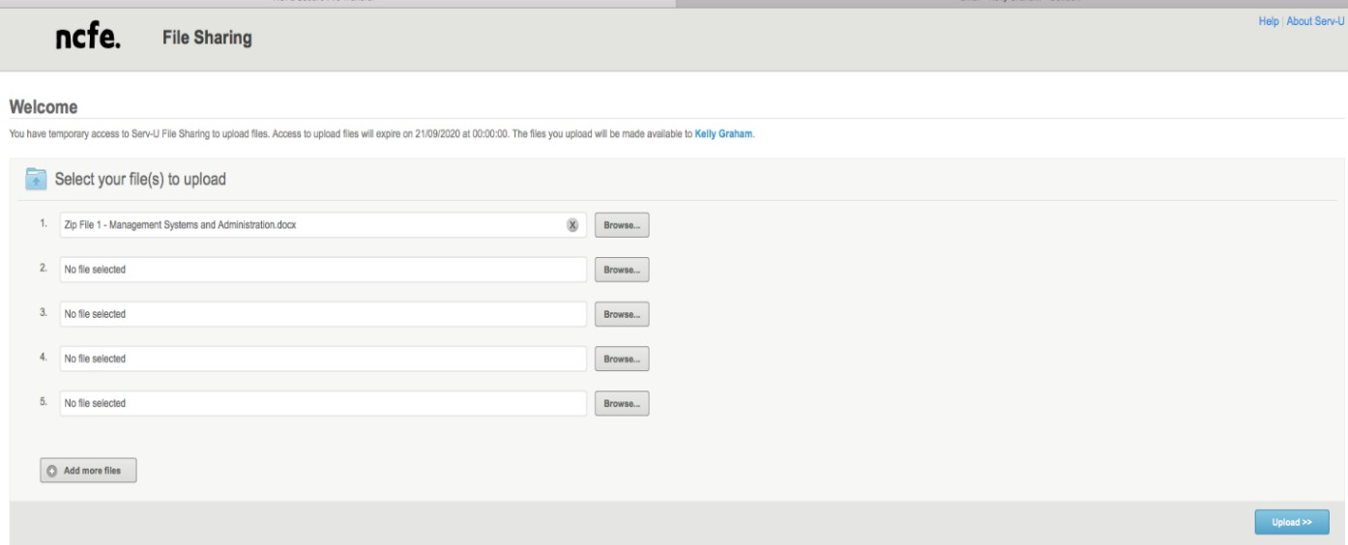

- The confirmation screen below shows that the files have been successfully uploaded

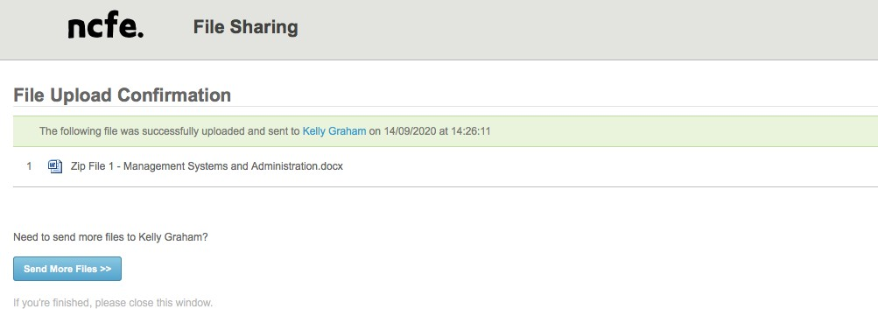

- If you need to send more files. Select ‘Select more files’ and follow the steps above.

OneDrive
If using OneDrive, we will grant you access to the folder you require. You will receive an email notification when a folder has been shared with you. Within this folder there will be subfolders, as labelled above.

Before you start to upload your files, you must ensure you have all the evidence required, as per the above Centre Guidance document and any additional evidence requested from your EQA/QR.
Once you have the information you can start to upload your files to the relevant folders. Files and folders must be:

- Clearly labelled, making it clear what the document is, which learner/unit/submission it relates to, where applicable
- Uploaded in full, rather than separate pages. Where documents are scanned, the pages must be uploaded the correct way up and must be of good quality.

Unacceptable sharing platforms

- Dropbox
- Google Drive
- Google docs
- WeTransfer

The platforms listed above are not to be used as file sharing platforms, this is because they are prime targets for cyber threats.
Version control:

Date approved
Approved by
Review date

Only approved versions of this document should be documented in the below table:
Version | Date | Revision author(s) | Summary of changes
V1.1 | 29.7.21 | Kelly Graham | Heading amended from Preparing for a Remote EQA Review to Preparing for a Remote Review  Information added around AMR, approval and moderation reviews  Infographic added to show file structure Information added around OneDrive
V1.2 | 29/06/22 | Kelly Graham | Information added around unacceptable sharing platforms.

