To be completed by the examiner | Mark
Section A
Section B
Part A
Part B
Part C
Part D
TOTAL MARK

NCFE Level 1 in Essential Digital Skills
603/7118/3
Topic: Buying a dog
Sample assessment material
Learner instructions  Answer all questions.  Read each question carefully.  Write your responses in the  spaces provided.  All of the work you submit must  be your own. | Learner information  The marks available for each  question are shown in brackets.  The maximum mark for this  paper is 59.  Time allowed: 2 hours and 25 minutes
Please complete the details below clearly and in BLOCK CAPITALS.
Learner name
Centre name
Learner number |  | Centre number

Do not turn over until instructed to do so by the Assessor

Section A
This section has a possible 17 marks.
You have 25 minutes to complete this section.
Answer all questions.
1 |  | Which of the following file sizes is the smallest?
 |  | [1 mark]
 |  | A | 15 GB
 |  | B | 23 KB
 |  | C | 83 MB
 |  | D | 12 TB
 |  | Answer

2 |  | Which one of the following describes an advantage of backing up to the cloud?
 |  | [1 mark]
 |  | A | It encrypts all files and password protects them
 |  | B | It provides unrestricted access
 |  | C | It safeguards data from damage or loss
 |  | D | It stores everything in a local area network
 |  | Answer

3 |  | Which one of the following describes the use of multi-factor authentication to gain access to a website?
 |  | [1 mark]
 |  | A | Entering a PIN and password to meet web-security regulations
 |  | B | Entering a username and a password to prove the user has permission
 |  | C | Presenting two or more pieces of evidence to verify the user’s identity
 |  | D | Presenting two pieces of personal information that only the user can know
 |  | Answer

4 |  | Jack is using social media.  Someone on social media keeps posting opinions that Jack does not agree with.  To stop seeing these posts, what should Jack do?
 |  | [1 mark]
 |  | A | Make a request for them to stop
 |  | B | Report them to the administrator
 |  | C | Tell everyone else what they have done
 |  | D | Use the app settings to block them
 |  | Answer

5 |  | Which one of the following protects a computer from trojans and worms?
 |  | [1 mark]
 |  | A | Installing a password manager application
 |  | B | Installing a virtual private network
 |  | C | Installing encryption software
 |  | D | Installing malware protection software
 |  | Answer

6 |  | Which one of the following is a reason for an account being removed from a social media platform?
 |  | [1 mark]
 |  | A | Not following the company’s policy
 |  | B | Not posting a status for 3 months
 |  | C | Not posting any photos on your account
 |  | D | Not replying to direct messages
 |  | Answer

7 |  | Charlie has been advised that overuse of his computer is affecting his sleep patterns. Which one of the following should Charlie do?
 |  | [1 mark]
 |  | A | Avoid using his computer right before going to bed
 |  | B | Ensure he exercises on the days when he works on his computer
 |  | C | Keep his back straight and wrists flexible when typing
 |  | D | Tilt his screen away from any lighting to avoid glare
 |  | Answer

8 |  | Tanveer wants to buy a book called Looking After Your Dog by someone called Curtis. Tanveer also wants to support shops in his local town of Westmouth but he does not know any local bookshops.  Which one of the following search terms would return the most accurate results?
 |  | [1 mark]
 |  | A | Looking After Your Dog, *Curtis, Westmouth
 |  | B | Looking After Your Dog, Curtis, Westmouth bookshop
 |  | C | “Looking After Your Dog’ Curtis ‘Westmouth bookshop’”
 |  | D | *Looking After Your Dog, Curtis, Westmouth
 |  | Answer

9 |  | Ayesha wants to chat to her friend in Canada about her upcoming visit.  Which one of the following is a private way for Ayesha to contact her friend?
 |  | [1 mark]
 |  | A | Commenting on her blog
 |  | B | Online forum
 |  | C | Posting on her social media page
 |  | D | Text message
 |  | Answer

10 |  | Eileen wants to uninstall some applications that she does not use from her personal computer. She has gone into Settings, then Apps & Features. Look at the image below and choose what Eileen should do next.  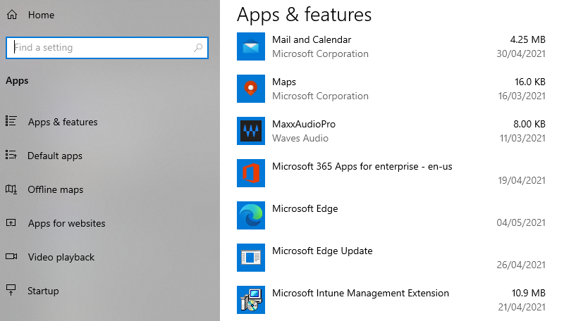
 |  | [1 mark]
 |  | A | Return to Settings because this is the incorrect screen to uninstall apps
 |  | B | Return to Start screen and select uninstall
 |  | C | Select the app and press delete
 |  | D | Select the app and select uninstall from the pop-up window
 |  | Answer

11 |  | Natalia has forgotten her password for her social media account.  When resetting her login credentials, which piece of personal information would Natalia be asked to confirm?
 |  | [1 mark]
 |  | A | Date of birth
 |  | B | Email address
 |  | C | Home address
 |  | D | Place of birth
 |  | Answer

12 |  | When buying online which one of the following would indicate that the website is secure?
 |  | [1 mark]
 |  | A | The customer satisfaction reviews are positive
 |  | B | There is a padlock symbol in the address bar
 |  | C | There is an option to use a credit card
 |  | D | There is an option to use a debit card
 |  | Answer

13 |  | Zi Chung needs to have a face-to-face discussion with four colleagues who live in different parts of the country.  Which one of the following would be the best way for Zi Chung to hold an online meeting?
 |  | [1 mark]
 |  | A | Developing an online blog
 |  | B | Logging in to an online forum
 |  | C | Posting on social media
 |  | D | Using a video collaboration tool
 |  | Answer

14 |  | Li has bought a printer and wants to share a positive review about the product to inform other customers. Which one of the following would do this effectively?
 |  | [1 mark]
 |  | A | Posting the details on her private family vlog
 |  | B | Posting the details on the company’s social media platform
 |  | C | Sending an email with the details to the Managing Director
 |  | D | Sending an email with the details to the Sales Manager
 |  | Answer

15 |  | Juan wants to order a laptop to have in time for a new college course he starts next week. He has identified two possible choices.  Which one of the following comparison options would help Juan decide?
 |  | [1 mark]
 |  | A | Delivery time
 |  | B | Device colour
 |  | C | Product marketing
 |  | D | Retailer brand
 |  | Answer

16 |  | Which one of the following cannot be done by adjusting email account settings?
 |  | [1 mark]
 |  | A | Changing a password
 |  | B | Choosing privacy settings
 |  | C | Deciding on the level of security
 |  | D | Increasing storage space
 |  | Answer

17 |  | Mia views a website and decides it is secure. She has also decided what she wants to buy.  What is the first action Mia should take during her online shop?
 |  | [1 mark]
 |  | A | Add her choice to the basket
 |  | B | Add her contact details
 |  | C | Choose the delivery method
 |  | D | Proceed to payment
 |  | Answer

Section B
This section has a possible 42 marks.
You have 120 minutes to complete this section.
The following table summarises the tasks.
Tasks | Task description | Marks
Part A | Storing data, searching online and communicating | 9
Part B | Working with text and images | 11
Part C | Working with data | 14
Part D | Storing data and transacting online | 8
Total |  | 42

Evidence you need to produce:
Where relevant, you must save your evidence to a secure storage space as your Assessor advises.

Part A
Storing data, searching online and communicating
Suggested time: 20 minutes
Marks available: 9

You work for a local dog shelter. Your manager has asked you to complete a number of tasks.
Your manager has asked you to research the best way to fundraise online for the organisation.

- Create a hierarchical folder structure with a folder named ‘Fundraising’.
Create two sub-folders named ‘websites’ and ‘social media’.
Download and open the Fundraising Websites document by clicking the download button below.
- Search the internet for two secure websites that support raising money for animal care.
Record the following information in your Fundraising Websites document:
- the search terms you used
- a screenshot of sponsored listings
- the URL of each website you have chosen.
c. Save your Fundraising Websites document to the websites folder you created.
Take a screenshot of your document in the folder. Save the screenshot in the folder 'Fundraising'.
d. Write an email to your manager using an appropriate subject line to tell them you have completed your research.
- x. Your manager’s email address is: learner@ncfe.org.uk
- x. Attach your Fundraising Websites document to your email. Send your email.
Take a screenshot of your sent email, showing the recipient, subject line and attachment. Save the screenshot in the folder 'Fundraising'.
Upload your Fundraising Websites document and screenshots using the upload link below.
Download the Fundraising Websites document: Upload your Fundraising Websites document and screenshots:
Click to upload
Click to download

- Create a social media post to tell your colleagues about the fundraising activity.
Include the hashtag ‘fundraising’. The post must be no longer than 280 characters.
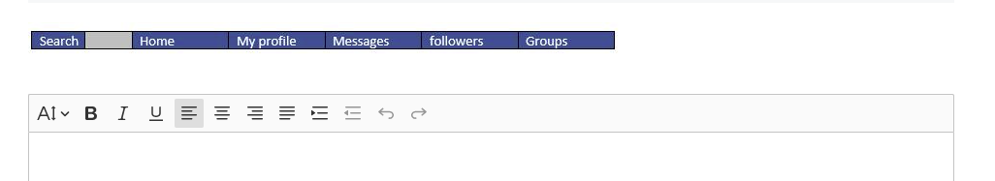

Part B
Working with text and images
Suggested time: 30 minutes
Marks available: 11
Your manager has provided you with a Dos and Don’ts file. You need to turn this into a flyer that can be given to customers who are interested in adopting a dog.
Download and open the Dos and Don’ts document by clicking the download button below.
a. Insert a table into the document that has two columns and two rows.
b. Position the Dos image within the first column, first row of the table.
x. Position the Don’ts image within the second column, first row of the table.
c. Position the Dos text in the cell under the Dos image.
x. Position the Don'ts text in the cell under the Don'ts image.
d. Crop the dog walker out of the photograph in the document.
e. Change the brightness and contrast of the image to 0%.
f. Apply a filter to the image.
g. Resize the image so it is 19 cm in height.
h. Add a border to the whole document.
i. Save the Dos and Don’ts document as Dos_and_Don’ts_FINAL and back-up to a local storage location.
x. You will be told which location you may use.
Take a screenshot of your document saved in a local storage location. Save it to the same local storage location as the Dos_and_Don’ts_FINAL.
Upload your Dos_and_Don'ts_FINAL document and your screenshot using the upload link below.
Download the Dos and Don’ts document: Upload your Dos_and_Don’ts_FINAL document and screenshot:
Click to download
Click to upload

Part C
Working with data
Suggested time: 40 minutes
Marks available: 14
Your manager has provided you with a spreadsheet showing the costs involved with owning a dog. You need to edit the spreadsheet before it can be given to customers.

Download and open the Costs of owning a dog spreadsheet by clicking the download button below.
a. Use AutoSum to calculate the Total for both columns containing the numeric values.
b. Using formulae, calculate the Total for first year in the appropriate cell, by adding the totals for Initial cost and Yearly costs.
c. Sort the Initial set-up items by ascending alphabetical order. Do not include the total.
d. Format all numeric values as currency to two decimal places.
e. Apply solid, black borders to all cells containing text and numeric data apart from the title. Cells that do not contain text and numeric data should not have borders.
f. Align all numeric values to the right of each cell.
g. Edit the bar chart on the spreadsheet to include the following:
- appropriate axis labels
- appropriate chart title
- numeric data labels for each bar.
h. Create a pie chart for the yearly costs data.
This must include a legend to show each section of the data series.
Format the data labels for each section to include values.
Add the chart title “Yearly costs of owning a dog”.
- Save your Costs of owning a dog spreadsheet as Costs_of_owning_a_dog_FINALto a cloud location you have been provided with by your Assessor.

Take a screenshot of the spreadsheet saved to the cloud location.
Upload your Costs_of_owning_a_dog_FINAL spreadsheet and your screenshot using the upload link below.
Upload your Costs_of_owning_a_dog_FINAL spreadsheet and screenshot:
Click to download
Click to upload
Download the Costs of owing a dog spreadsheet:

Part D
Storing data and transacting online
Suggested time: 30 minutes
Marks available: 8
Your manager has asked you to research and compare dry dog food options that could be used for one of the new dogs at the shelter. You have been provided with details of the dog.
Download and open the Bruno Dog Profile document by clicking on the download button below.
a. Enter appropriate search terms into a search engine to find a website that sells dry dog food.
Take a screenshot of the search terms in the search bar and paste into the Bruno Dog Profile document.
Select a website from your search results. Visit the website and use the search filters to find the flavour of dry dog food that Bruno prefers and that is suitable for his life stage.
Sort the products by price (lowest to highest).
Take a screenshot of your search results on the website and save it to the Bruno Dog Profile document.
Take a screenshot of the product with the lowest price and save it to the Bruno Dog Profile document.
b. Search another website for the same product you have selected.
Add the following information to the Bruno Dog Profile document:
• the URLs of the websites
• the product name
• the prices from both websites.

Save the document as Bruno_Dog_Profile_FINAL.
Upload your Bruno_Dog_Profile_FINAL document using the upload link below.
Download the Bruno Dog Profile document: Upload your Bruno Dog Profile document:
Click to download
Click to upload
- Compare both dry dog food options and enter the price of the cheaper item in the box below.

- Select VISA debit card as the payment option.

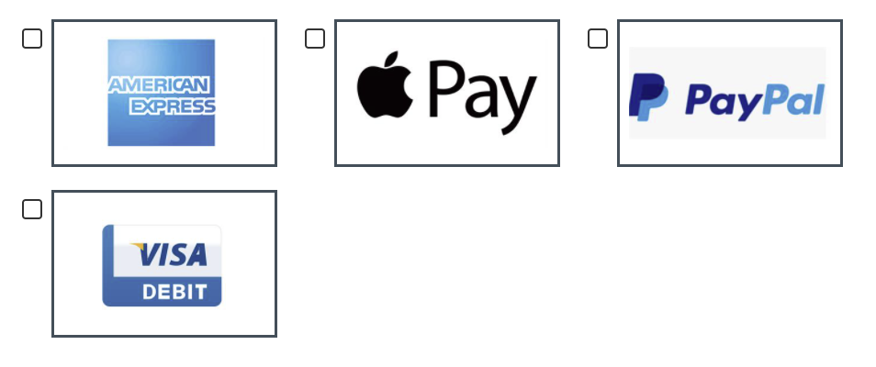

- Use the card details provided on screen to complete the payment form.

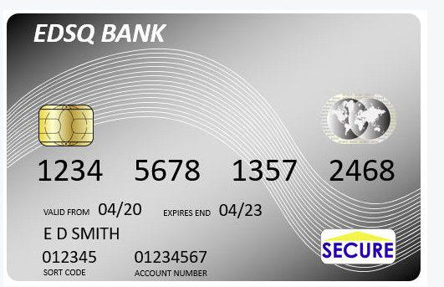

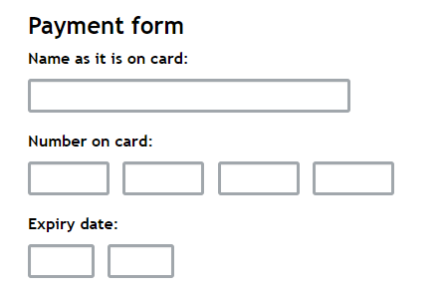

- Confirm and submit the payment.

This is the end of the internal assessment.

Document information
Owner: Joanna Fairless, Head of Assessment Design

Change History Record
Version | Description of change | Approval | Date of Issue
v0.1 | First draft |  | November 2019
v0.2 | Feedback incorporated |  | September 2020
v0.3 | Reformatted with new document style |  | December 2020

